IU2541230066 – CPP42 – PROJECT REPORT
Wedding Event Management
ENROLLMENT NO: IU2541230066
STUDENT NAME: MAHIR P. DOSHI
SEMESTER : 3
SUBJECT : C++ GUIDED PROJECT

Introduction

The Wedding Event Management System is a menu-driven application developed using C++ to manage the essential activities involved in organizing wedding events. The system helps maintain records of clients, venues, services, and bookings in an organized and efficient manner.
The application allows the wedding event manager to add client details, manage venue and service information, create bookings, calculate the total booking amount, display all records, search for specific records, update existing information, and delete records when permitted. It uses file handling to store data in text files so that records can be retained and loaded when the application is run again.
The project demonstrates important Object-Oriented Programming (OOP) concepts, including classes and objects, encapsulation, inheritance, and polymorphism. It also uses dynamic memory allocation to manage record collections and separates responsibilities across different classes, such as Client, Venue, Service, Booking, EventManager, and FileManager.
The main purpose of this project is to apply C++ programming concepts to a practical management problem while improving data organization, record handling, and the overall efficiency of wedding event management.

Problem Statement

Managing wedding events involves handling various details, such as client information, venue availability, service selection, booking details, and cost calculations. Managing these records manually can be time-consuming and may lead to errors, duplicate entries, difficulty in retrieving information, and problems maintaining updated records.
The Wedding Event Management System aims to solve these problems by providing a centralized, menu-driven C++ application for managing clients, venues, services, and bookings. The system allows the wedding event manager to add, search, display, update, and delete records, while also calculating the total cost of a booking based on the selected venue and services.
The application uses file handling to store records in text files, allowing data to be loaded and reused when the program runs again. Therefore, the project focuses on improving the organization and management of wedding-related information while demonstrating the practical application of Object-Oriented Programming concepts in C++.

Objectives

The objectives of the Wedding Event Management System are grouped into the following modules:

3.1 Client Management Module
- To add and maintain client details, including client ID, name, and contact information.
- To display, search, update, and delete client records.

3.2 Venue Management Module
- To add and maintain venue details, including venue ID, name, capacity, rent, and availability.
- To check venue availability before creating a booking.
- To display, search, update, and delete venue records.

3.3 Service Management Module
- To add and maintain wedding service details, including service ID, service name, and cost.
- To allow the selection of services during booking creation.
- To display, search, update, and delete service records.

3.4 Booking Management Module
- To create bookings by associating a client, venue, event date, and selected services.
- To validate client and venue IDs before creating a booking.
- To calculate the total booking amount using venue rent and selected service costs.
- To display booking details and the final booking amount.

3.5 Record Management Module
- To provide a menu-driven interface for displaying, searching, updating, and deleting records.
- To validate user input and handle invalid or unavailable records appropriately.
- To maintain organized records for efficient retrieval and modification.

3.6 File Handling Module
- To save client, venue, service, and booking records in text files.
- To load previously saved records when the application starts.
- To preserve data between program executions.

3.7 Object-Oriented Programming and Memory Management Module
- To demonstrate classes, objects, encapsulation, inheritance, and polymorphism.
- To use constructors and destructors for object initialization and cleanup.
- To demonstrate dynamic memory allocation for managing record collections.
- To organize the application into separate classes for better modularity and maintainability.

Functional Requirements

The functional requirements of the Wedding Event Management System describe the operations that the application must perform to manage clients, venues, services, and bookings.

4.1 Client Management
- The system shall allow the user to add client details, including client ID, name, and phone number.
- The system shall display all stored client records.
- The system shall allow the user to search for a client using the available search functionality.
- The system shall allow existing client records to be updated or deleted.

4.2 Venue Management
- The system shall allow the user to add venue details, including venue ID, name, capacity, rent, and availability.
- The system shall maintain venue information for booking operations.
- The system shall display, search, update, and delete venue records.
- The system shall check venue availability during booking creation.

4.3 Service Management
- The system shall allow the user to add wedding service details, including service ID, service name, and cost.
- The system shall maintain service information for booking operations.
- The system shall display, search, update, and delete service records.
- The system shall allow services to be selected while creating a booking.

4.4 Booking Management
- The system shall allow the user to create a booking by entering a booking ID, client ID, venue ID, and event date.
- The system shall verify that the specified client and venue exist before creating a booking.
- The system shall check venue availability before confirming a booking.
- The system shall allow the selection of services for a booking and prevent duplicate service selections where implemented.
- The system shall calculate the total booking amount using the venue rent and selected service costs.
- The system shall display the booking details and final bill.

4.5 Record Search, Update, and Delete
- The system shall provide menu options to search, update, and delete records.
- The system shall allow users to select the relevant record category and enter the required record ID.
- The system shall display the matching record or an appropriate message if the record is not found.
- The system shall validate updated information before modifying an existing record.
- The system shall remove selected records through the delete operation, subject to any restrictions implemented in the program.

4.6 File Handling and Data Persistence
- The system shall store client, venue, service, and booking records in their respective text files.
- The system shall load previously saved records when the application starts.
- The system shall save changes to the relevant files when records are modified through operations that trigger persistence.
- The system shall retain saved information between program executions, provided the data files remain available and readable.

4.7 Menu and Input Validation
- The system shall display a menu for selecting the available operations.
- The system shall accept user input for record creation, search, update, and deletion.
- The system shall validate relevant inputs and identifiers before performing operations.
- The system shall display appropriate success, error, or not-found messages.
- The system shall allow the user to exit the application through the menu.

System / Project Workflow

The Wedding Event Management System follows a menu-driven workflow in which the wedding event manager performs operations through a console interface. The system manages client, venue, service, and booking records using separate C++ classes and stores data in text files for persistence.

5.1 Overall System Workflow
- Start the Application: The program starts from main.cpp and creates an EventManager object.
- Initialize Records: The system loads previously saved records from the respective text files.
- Display Main Menu: The system displays the available operations:
  - Add Client
  - Add Venue
  - Add Service
  - Add Booking
  - Display All Records
  - Search Record
  - Update Record
  - Delete Record
  - Exit
- Select an Operation: The wedding event manager selects an operation by entering the corresponding menu option.
- Process the Request: The EventManager class performs the requested operation on the appropriate record collection.
- Validate Input: The system checks the required inputs and identifiers before performing relevant operations.
- Save Changes: For operations that modify data, the system saves the changes to the respective text files through FileManager.
- Display the Result: The system displays the operation result or an appropriate error message.
- Repeat or Exit: The system returns to the main menu for another operation or terminates when the user selects Exit.

5.2 Booking Creation Workflow
- The wedding event manager selects Add Booking from the main menu.
- The system accepts the booking details, including the client ID, venue ID, and event date.
- The system checks whether the specified client and venue exist.
- The system checks the venue's availability.
- The user selects the required wedding services.
- The system calculates the total amount by adding the venue rent and the costs of the selected services.
- The system creates the booking record with the relevant details and calculated amount.
- The system displays the booking details and final bill.
- The relevant records are saved to the text files.

5.3 Search, Update, and Delete Workflow
- The wedding event manager selects Search, Update, or Delete Record from the main menu.
- The user specifies the record category and required record ID.
- The system searches the corresponding in-memory record collection.
- If a matching record is found, the system performs the requested operation.
- For an update, the system accepts new details and modifies the existing record.
- For deletion, the system removes the selected record according to the implemented rules.
- The system saves applicable changes through FileManager.
- The system displays a success message or an appropriate error message.

5.4 Workflow Representation
Overall flow:
Start → Initialize EventManager → Load Records → Display Main Menu → Select Operation → Validate Input → Process Operation → Save Changes (where applicable) → Display Result → Return to Menu / Exit
Booking flow:
Select Add Booking → Validate Client and Venue → Check Venue Availability → Select Services → Calculate Total → Create Booking → Display Bill → Save Records → Return to Menu
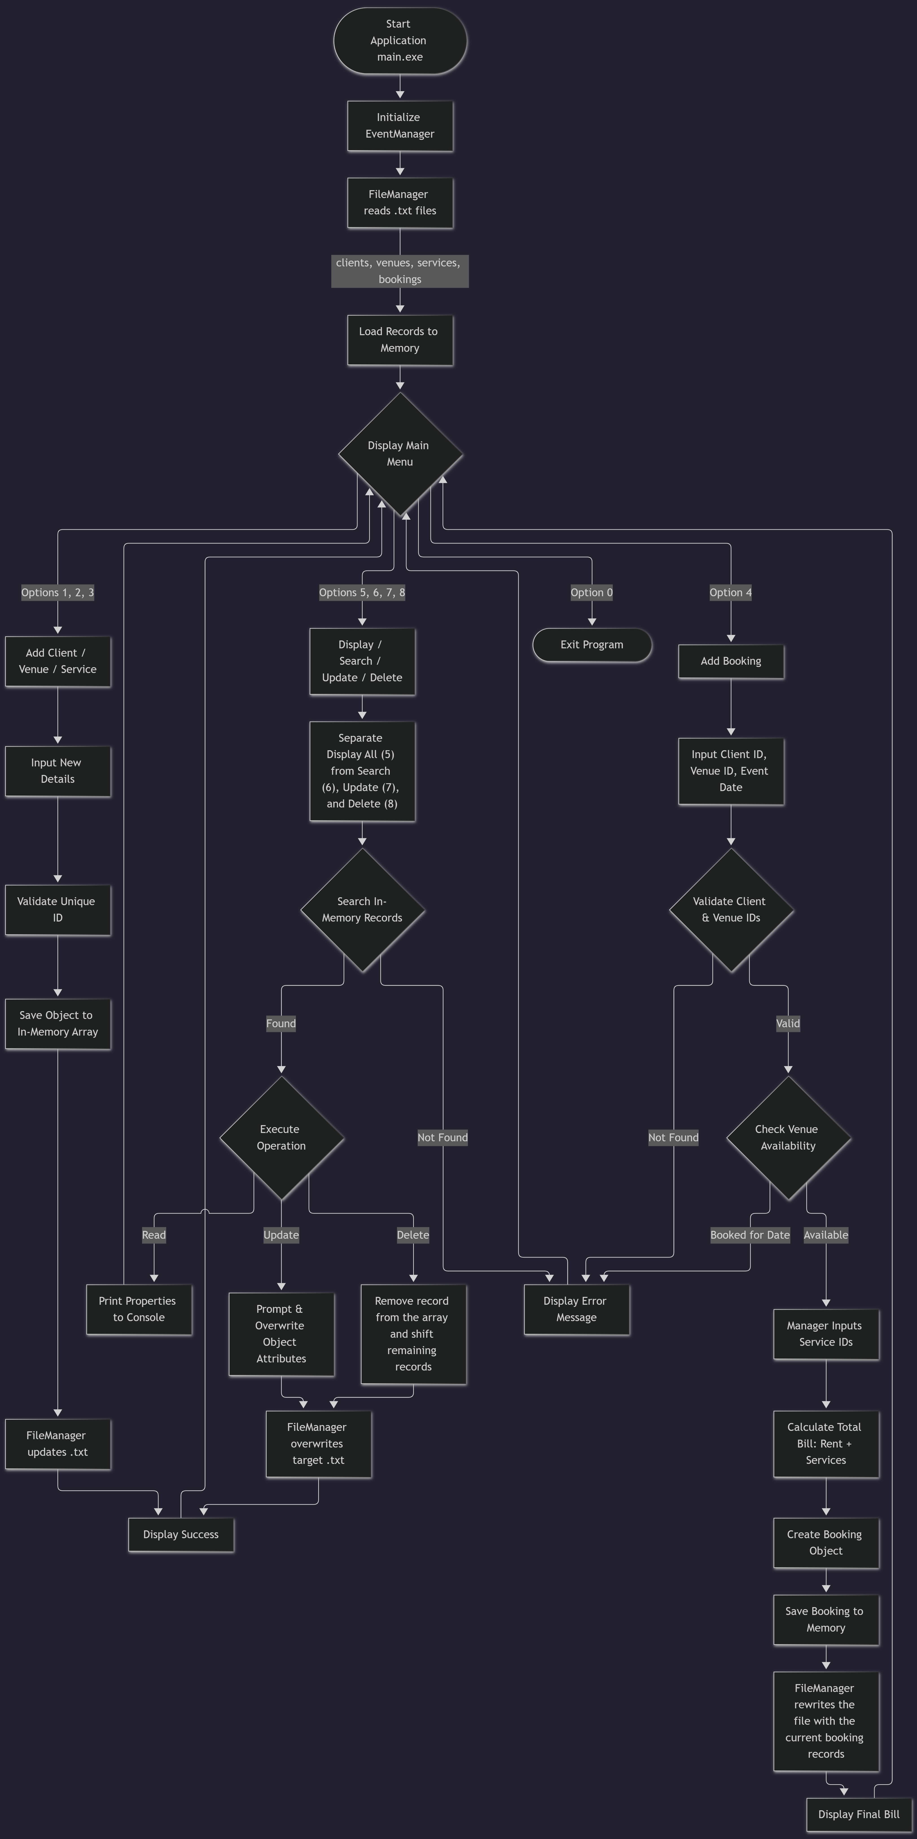

Class Representation

CLASS | DATA MEMBES | MEMBER FUNCTION | RESPONSIBILITY
Person | - id: int  - name: string | Person()  Person(int, string)  virtual ~Person()  virtual display()  getId(), getName() | Base class that stores shared identity information and defines a virtual display function.
Client : Person | - phone: string | Client()  Client(int, string, string)  display() override  getPhone() | Stores client phone number and reuses ID/name members inherited from Person.
Venue | - venueId: int  - venueName: string  - capacity: int  - rent: double  - available: bool | Venue()  Venue(int, string, int, double, bool)  display(), isAvailable()  getters and setters | Stores the venue details, capacity, rent and availability flag used during booking checks.
Service | - serviceId: int  - serviceName: string  - cost: double | Service()  Service(int, string, double)  display() and getters  setServiceName(), setCost() | Represents an additional wedding service and its price.
Booking | - bookingId: int  - clientId: int  - venueId: int  - eventDate: string  - totalAmount: double  - confirmed: bool | Booking()  Booking(int, int, int, string, double)  display() and getters  setEventDate(), setTotalAmount()  confirmBooking() | Stores booking identifiers, date, total amount and confirmation status. Selected service IDs are not stored separately.
EventManager | Client*, Venue*, Service*, Booking*  Four counts; MAX_RECORDS = 100 | EventManager(), ~EventManager()  menu()  add*/display* methods  searchRecord(), updateRecord(), deleteRecord()  saveAll(), clientExists(), venueExists() | Controls the menu, dynamic arrays, validation, record operations, booking flow and persistence calls.
FileManager | No instance data members; file streams are local to methods. | static save/load Clients  static save/load Venues  static save/load Services  static save/load Bookings | Loads and saves each record collection to its matching text file.

7 OOPS CONCEPTS
The Wedding Event Management System demonstrates the following Object-Oriented Programming (OOP) concepts in C++.
OOP Concept | Implementation in the Project | Purpose / Explanation
Classes and Objects | Classes such as Person, Client, Venue, Service, Booking, EventManager, and FileManager. | Classes organize related data and functions. Objects represent individual clients, venues, services, and bookings.
Encapsulation | Data members and member functions are grouped within individual classes. | Keeps related data and operations together and organizes the program into manageable units.
Inheritance | Client inherits from the Person class. | Allows Client to reuse common information, such as ID and name, from Person.
Polymorphism | The Person class declares a virtual display() function, which is overridden by Client. | Allows the appropriate display function to be used for different types of person objects through polymorphism.
Abstraction | EventManager coordinates application operations, while FileManager handles file operations. | Separates the main application logic from data storage operations and hides unnecessary implementation details from other parts of the program.
Constructors | Classes provide default constructors and, where defined, parameterized constructors. | Initialize objects when they are created.
Destructors | Destructors are used for object cleanup; Person has a virtual destructor, and EventManager releases dynamically allocated resources. | Help manage object lifetimes and release resources when objects are destroyed.
Dynamic Memory Allocation | EventManager uses pointers for dynamically allocated arrays of Client, Venue, Service, and Booking objects. | Allows record collections to be managed in dynamically allocated memory, subject to the project's maximum record capacity.
Modularity | The program separates functionality into classes and corresponding header/source files. | Improves code organization, readability, maintenance, and reuse.

These concepts help make the Wedding Event Management System organized, modular, and easier to maintain. The project particularly demonstrates inheritance and polymorphism through the relationship between Person and Client, along with dynamic memory management through EventManager.

8. File Handling and Data Persistence

The Wedding Event Management System uses file handling in C++ to store and retrieve client, venue, service, and booking records. The FileManager class is responsible for saving data to text files and loading previously saved records when the application starts. This allows the system to maintain data between program executions.

8.1 Files Used in the Project
The system uses four text files for data storage.
File Name | Data Stored | Purpose
clients.txt | Client ID, name, and phone number | Stores client information.
venues.txt | Venue ID, name, capacity, rent, and availability | Stores venue details.
services.txt | Service ID, service name, and cost | Stores wedding service information.
bookings.txt | Booking ID, client ID, venue ID, event date, total amount, and confirmation status | Stores booking information.

8.2 File Handling Operations
The FileManager class uses C++ file streams to perform input and output operations.
Operation | Description
Saving Records | The saveClients(), saveVenues(), saveServices(), and saveBookings() functions write records to their respective text files.
Loading Records | The corresponding loadClients(), loadVenues(), loadServices(), and loadBookings() functions read previously saved records into memory.
File Creation and Overwriting | Output streams using ofstream create the file if needed and overwrite its existing contents when opened for saving.
File Reading | Input streams using ifstream read stored records from the text files.
Record Count Storage | Each file stores the number of records on the first line, followed by the corresponding record data.
Error Handling | The functions return success or failure status. The system displays a success message when all records are saved or loaded successfully, and a warning if an operation fails.

8.3 Data Persistence Workflow
The application follows these steps to manage persistent data:
- When the program starts, the EventManager constructor dynamically allocates memory for the record arrays.
- The constructor calls the FileManager loading functions to retrieve clients, venues, services, and bookings from their respective files.
- The loaded records are stored in memory for use by the application.
- The wedding event manager performs operations such as adding, updating, deleting, or creating bookings.
- When the relevant operation triggers saving, EventManager::saveAll() calls all four saving functions.
- The latest record collections are written to their respective text files.
- When the application runs again, the saved records can be loaded back into memory.
If a data file does not exist, the corresponding loading function initializes the record count to zero and reports successful loading for that file.

8.4 Role of the FileManager Class
The FileManager class separates file operations from the main application logic. Its functions are declared as static, so they can be called directly without creating a separate FileManager object.
The EventManager class coordinates data management, while FileManager handles reading and writing the files. This separation improves modularity and makes the program easier to maintain.
Thus, file handling and data persistence allow the Wedding Event Management System to store, retrieve, and manage records across different program executions.

9. UML Diagrams
USE CASE DIAGRAM
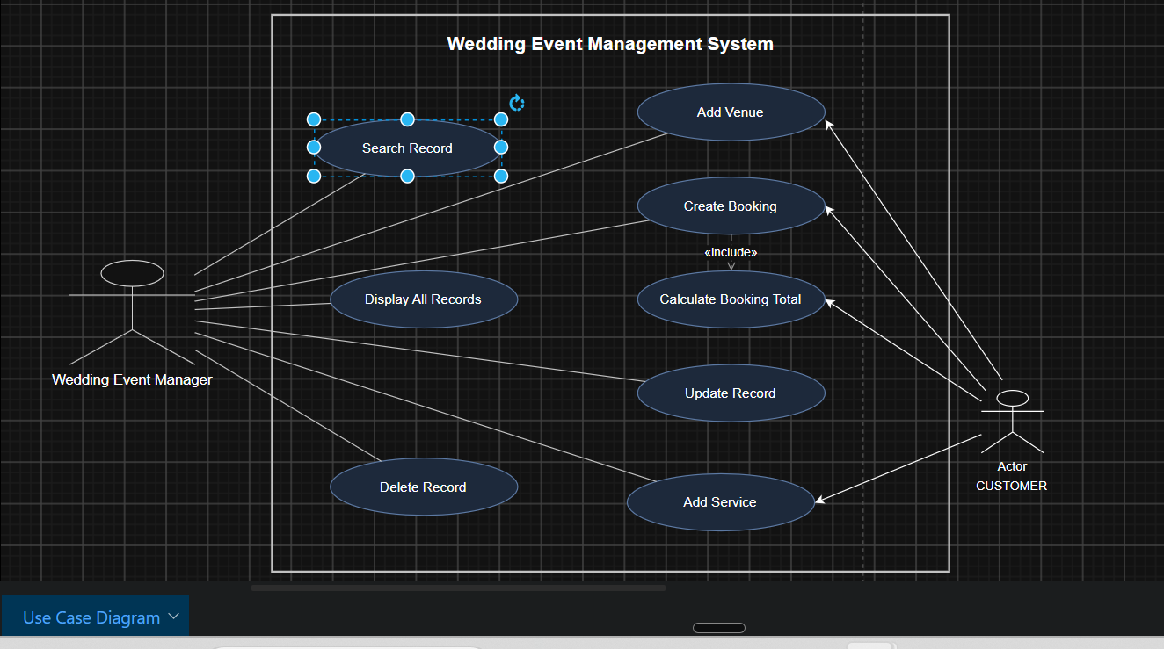

CLASS DIAGRAM

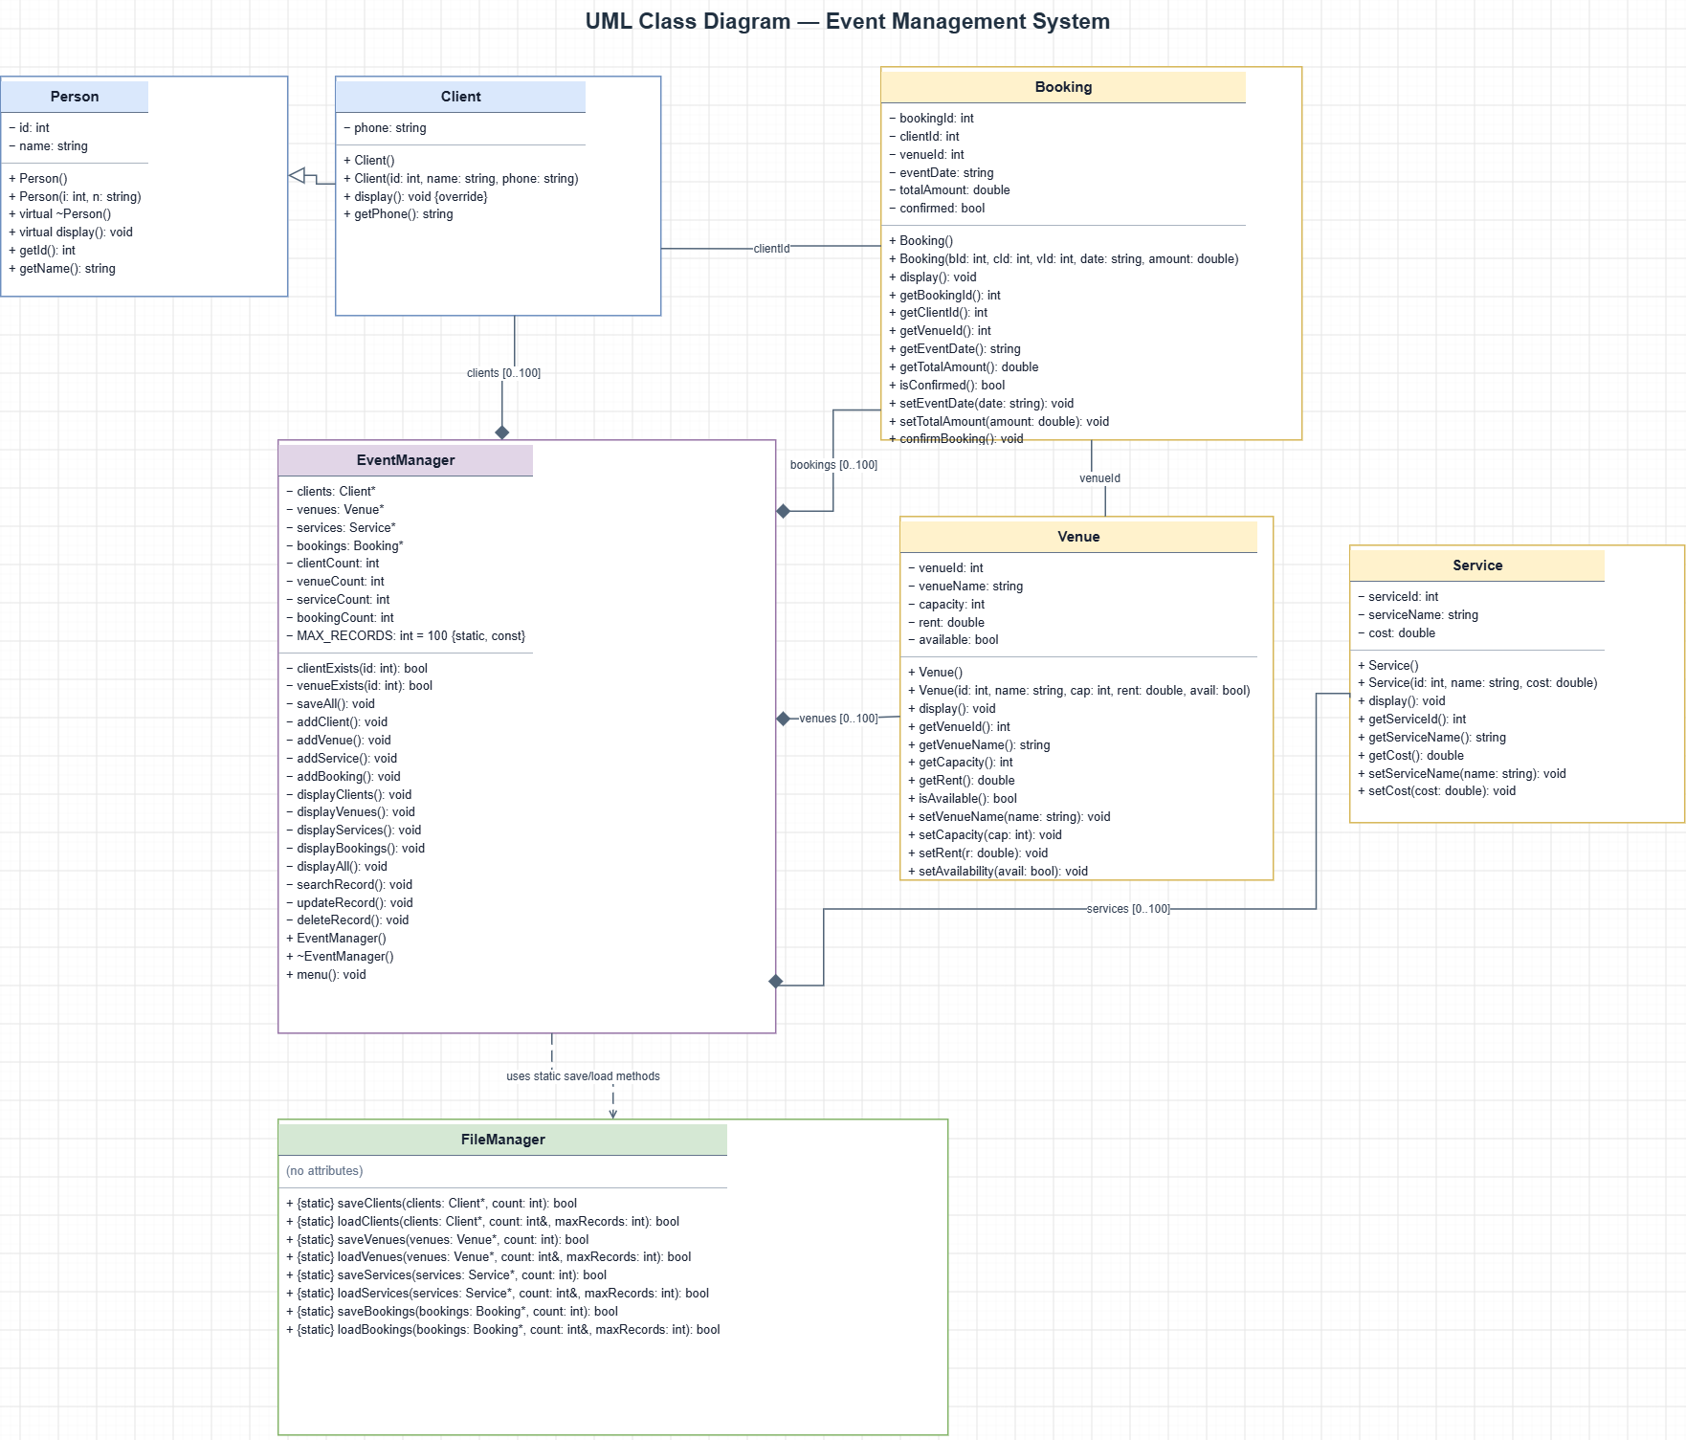

SEQUENCE DIAGRAM : 1
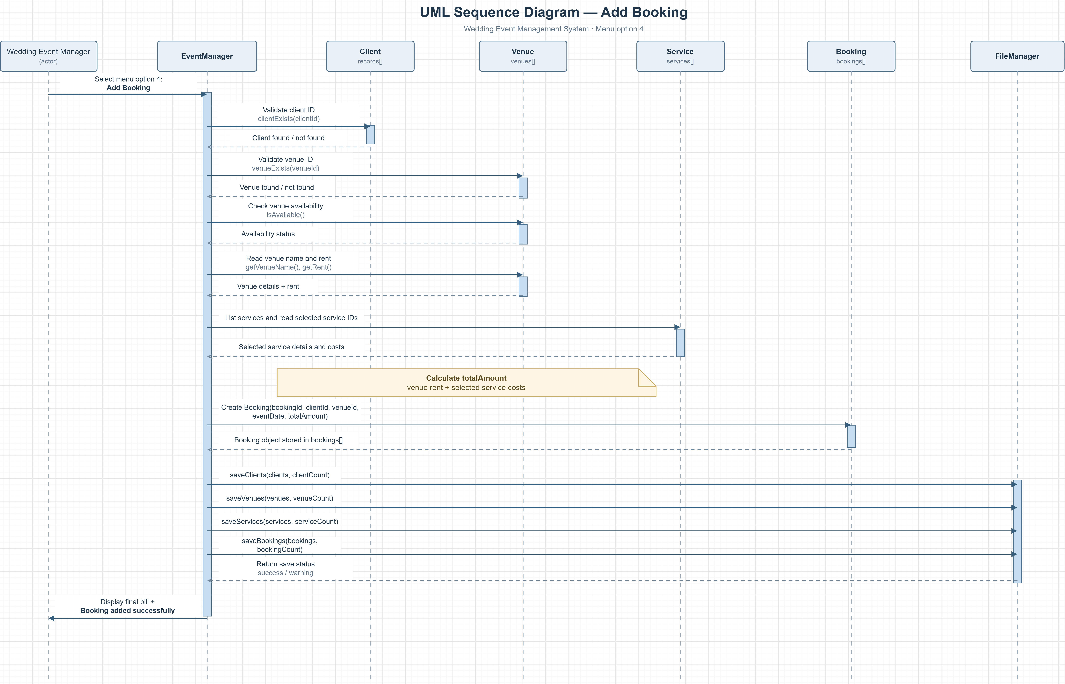

SEQUENCE DIAGRAM : 2

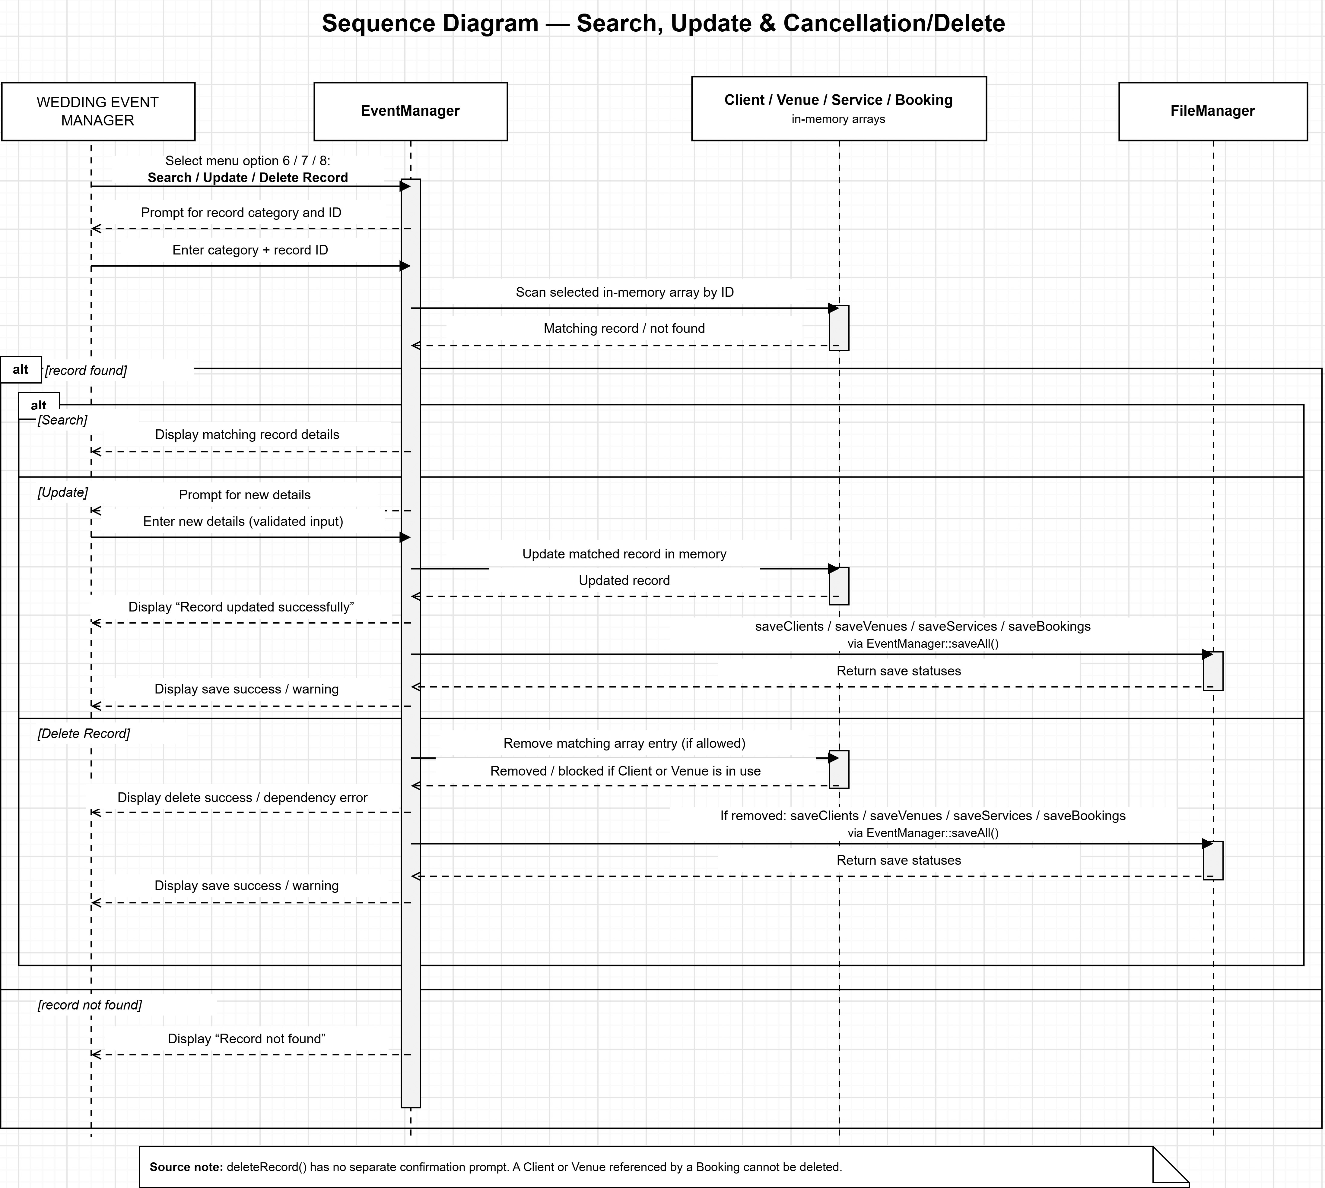

10. Implementation Details

The Wedding Event Management System is implemented using C++ and follows a menu-driven approach. The program uses separate classes to manage clients, venues, services, bookings, and file operations. The implementation demonstrates object-oriented programming, dynamic memory allocation, input validation, record management, and file handling.

10.1 Programming Language and Development Structure
The project is developed in C++ and organized into header files (.h) and source files (.cpp) to keep class declarations and implementations separate.
File Name | Implementation Details
main.cpp | Contains the main() function, creates an EventManager object, and starts the main menu. It also handles standard exceptions.
Person.h / Person.cpp | Defines the base Person class, which stores a person's ID and name and provides a virtual display() function.
Client.h / Client.cpp | Implements the Client class, which inherits from Person and stores the client's phone number.
Venue.h / Venue.cpp | Defines venue details, including ID, name, capacity, rent, and availability, along with related member functions.
Service.h / Service.cpp | Implements the service class for storing wedding service details and costs.
Booking.h / Booking.cpp | Implements the booking class for storing booking IDs, associated client and venue IDs, event date, total amount, and confirmation status.
EventManager.h / EventManager.cpp | Contains the main application logic, menu operations, record management, booking creation, validation, and coordination of file saving and loading.
FileManager.h / FileManager.cpp | Provides static functions to save and load clients, venues, services, and bookings using text files.

10.2 Menu-Driven Implementation
The EventManager class provides the main menu through its menu() function. The wedding event manager selects an operation by entering the corresponding option.
Menu Option | Operation | Implementation
1 | Add Client | Accepts client information, checks the client ID, stores the record in memory, and saves the records.
2 | Add Venue | Accepts venue details, checks the venue ID, stores the record, and saves the records.
3 | Add Service | Accepts service details, checks the service ID, stores the record, and saves the records.
4 | Add Booking | Validates client and venue IDs, checks venue availability, selects services, calculates the total amount, and creates the booking.
5 | Display All Records | Displays the stored client, venue, service, and booking records.
6 | Search Record | Searches the selected in-memory record collection using its ID.
7 | Update Record | Finds an existing record and modifies its supported fields.
8 | Delete Record | Finds and deletes a record, subject to the restrictions implemented in the program.
0 | Exit | Saves all record collections and terminates the menu loop.

10.3 Object-Oriented Implementation
The system uses multiple classes to organize the program into separate responsibilities.
The Person class acts as a base class, while Client inherits from it. The virtual display() function in Person is overridden in Client, demonstrating runtime polymorphism.
The Venue, Service, and Booking classes store their respective data and provide member functions to display, retrieve, or update supported information. The EventManager class coordinates these objects and manages the application's operations, while FileManager handles file-related tasks.

10.4 Dynamic Memory Management
The EventManager class uses dynamically allocated arrays to maintain records of clients, venues, services, and bookings. The arrays are allocated using the new[] operator, with a maximum capacity of 100 records for each collection.
The class maintains separate counters for the number of clients, venues, services, and bookings stored. Before adding a record, the program checks whether the corresponding array has reached its capacity.
The EventManager destructor uses delete[] to release the dynamically allocated arrays when the object is destroyed.

10.5 Booking Processing and Bill Calculation
Booking creation is one of the main operations of the application. The addBooking() function performs the following steps:
- Checks whether record capacity is available and whether clients and venues have been added.
- Accepts the booking ID and checks for duplicate booking IDs.
- Accepts the client ID and verifies that the client exists.
- Accepts the venue ID and verifies that the venue exists.
- Checks the venue's current availability status.
- Accepts the event date and initializes the total amount using the venue rent.
- Displays available services and accepts the required service IDs.
- Rejects invalid service IDs and prevents selecting the same service more than once within the booking.
- Adds the selected service costs to the venue rent.
- Creates the booking object, displays the final bill, and saves all record collections.
The total booking amount is calculated as:
Total Booking Amount = Venue Rent + Total Cost of Selected Services

10.6 Search, Update, and Delete Operations
The searchRecord(), updateRecord(), and deleteRecord() functions provide record management functionality.
- Search: The user selects a record category and enters an ID. The system searches the corresponding in-memory array and displays the matching record or a not-found message.
- Update: The system searches for the selected record and accepts new information for supported fields. After a successful update, the record collections are saved.
- Delete: The system searches for the selected record and removes it by shifting the remaining array elements. A client or venue cannot be deleted if an existing booking references it. Successful deletion is followed by saving the records.

10.7 Input Validation and Error Handling
The program uses input helper functions to improve the reliability of console input. These functions validate integers, positive integers, non-negative numeric values, and non-empty text fields.
The system also checks for duplicate IDs when adding records and verifies the existence of clients, venues, services, and bookings where required. Appropriate messages are displayed when invalid input is entered, a record is not found, storage is full, or a file operation fails.
The main() function uses a try-catch block to handle standard exceptions and display an error message if an unexpected exception occurs.

10.8 Integration of File Handling
The EventManager constructor allocates memory for the record arrays and calls the FileManager loading functions to retrieve saved records from the respective text files.
The saveAll() function calls the saving functions for clients, venues, services, and bookings. It is used after successful record additions, updates, deletions, booking creation, and when the user exits the program.
This design separates record management from file operations and allows the application's data to be retained between program executions.

11. Testing and Results
Test ID | Input / Operation | Expected | Actual | Status
T01 | Start with no data files | System starts with empty collections. | Menu displayed; exit saved empty files. | PASS
T02 | Add client ID 1 | Client accepted and persisted. | Client added; clients.txt updated. | PASS
T03 | Add duplicate client ID 1 | Duplicate is rejected. | Duplicate-ID error shown. | PASS
T04 | Add venue ID 10 | Venue saved with capacity and rent. | Venue added and all files saved. | PASS
T05 | Add service ID 20 | Service saved with its cost. | Service added and all files saved. | PASS
T06 | Book venue rent 50000 + service 12000 | Total bill is 62000. | Total Booking Amount: 62000. | PASS
T07 | Booking with unknown client ID 999 | Booking is rejected. | Client not found message shown. | PASS
T08 | Search Client ID 1 | Matching details are displayed. | Name and phone displayed. | PASS
T09 | Search unknown ID 999 | Not-found message is displayed. | Record not found message shown. | PASS
T10 | Update service ID 20 | New service name/cost are saved. | Updated details persisted in services.txt. | PASS
T11 | Update unknown record ID 999 | Update is not performed. | Record not found message shown. | PASS
T12 | Delete service ID 20 | Service is removed and saved. | Success message; file count became zero. | PASS
T13 | Delete client referenced by booking | Deletion is blocked. | Reference-protection message shown. | PASS
T14 | Enter non-numeric menu choice | Input is rejected and retried. | Invalid-input message shown. | PASS
T15 | Restart after adding a client | Saved record loads again. | Client displayed after restart. | PASS

12. Sample Screens / Output
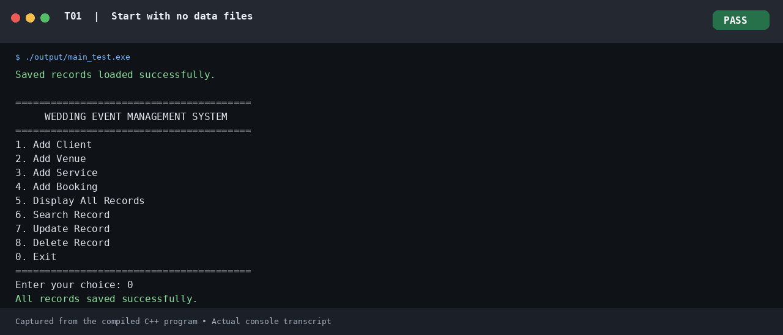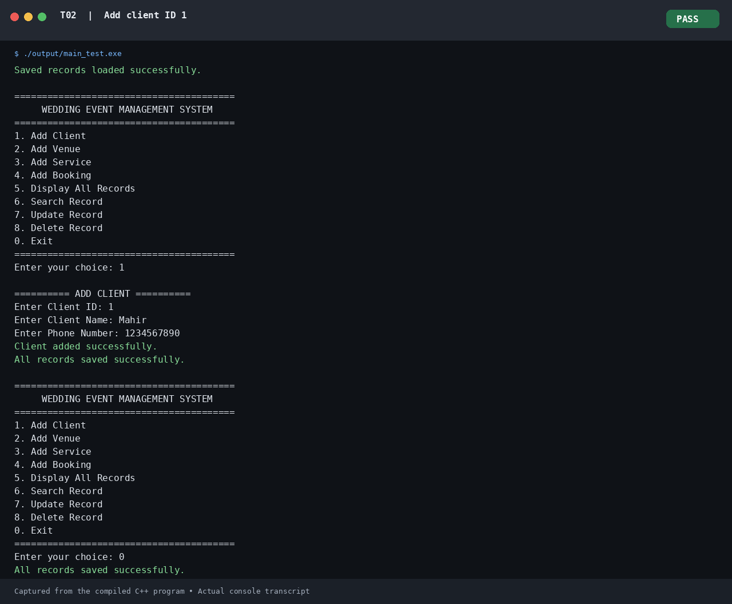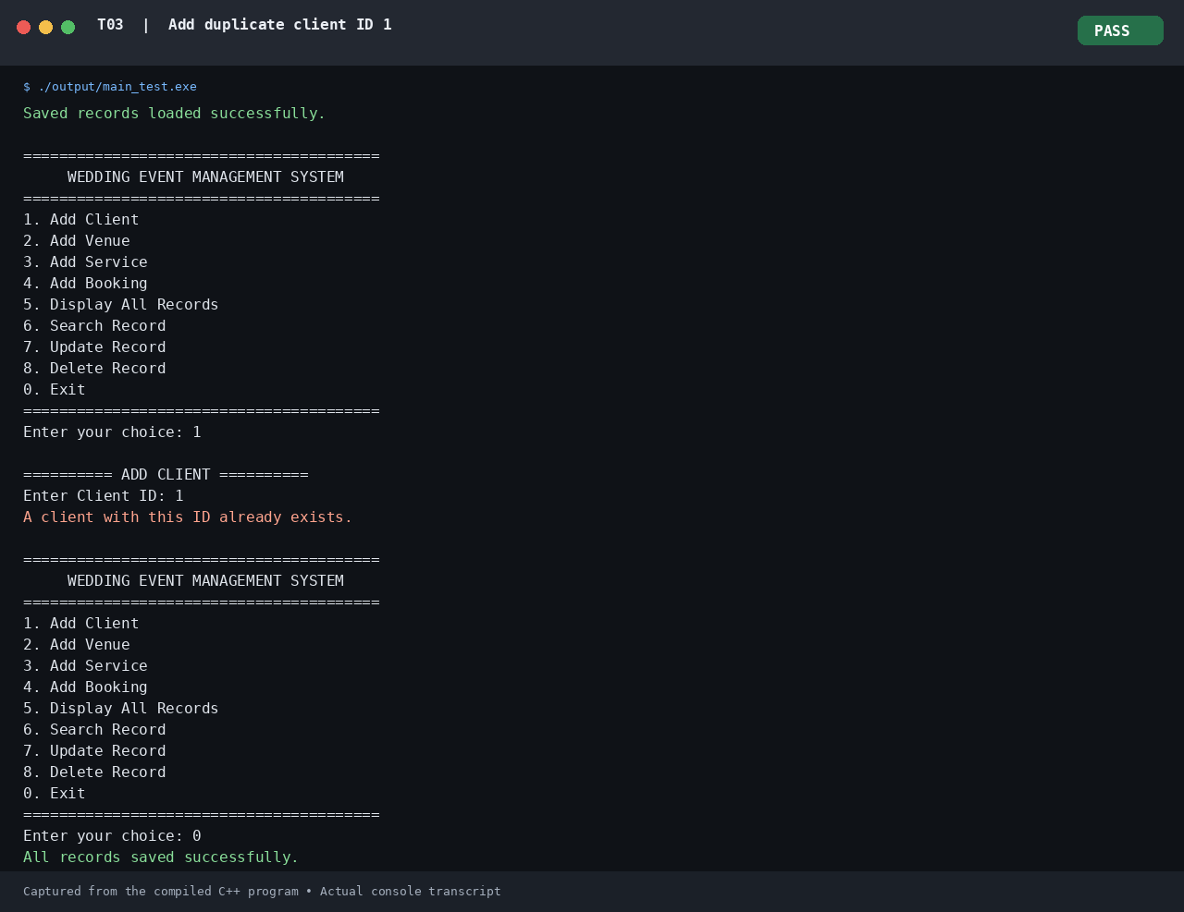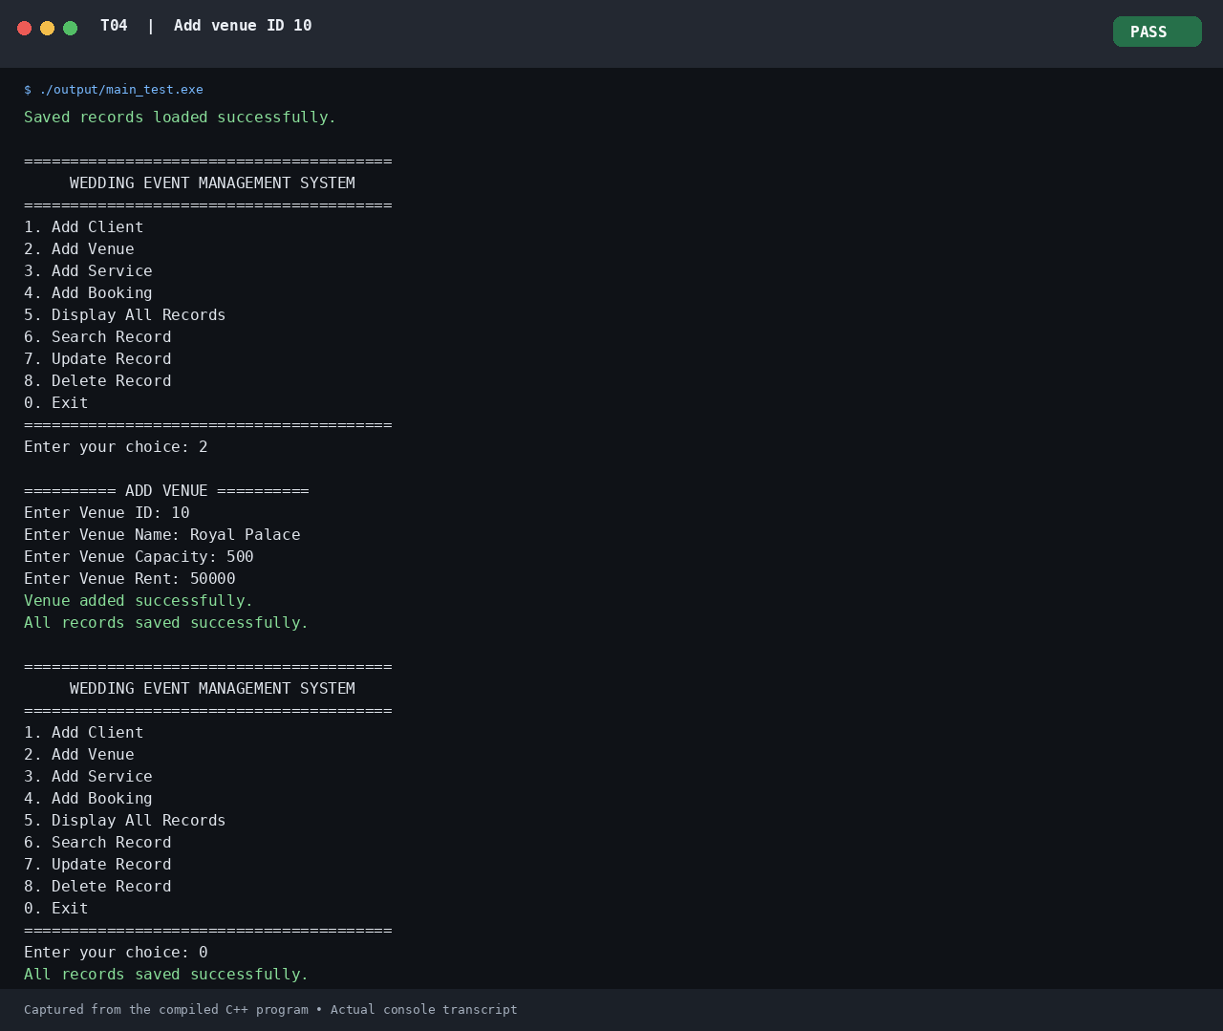
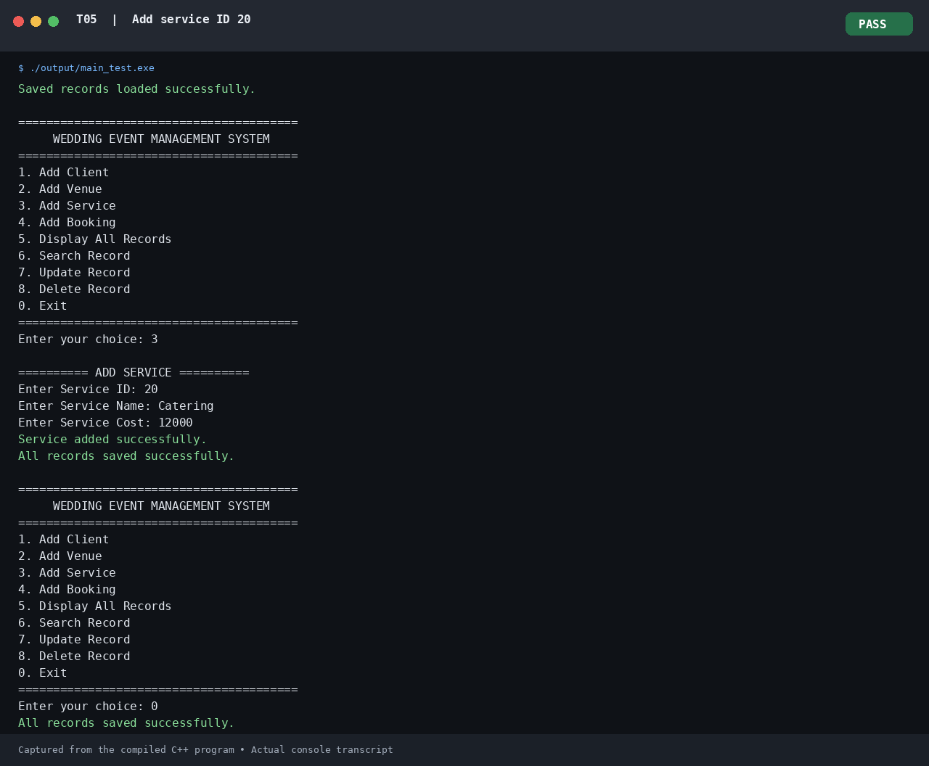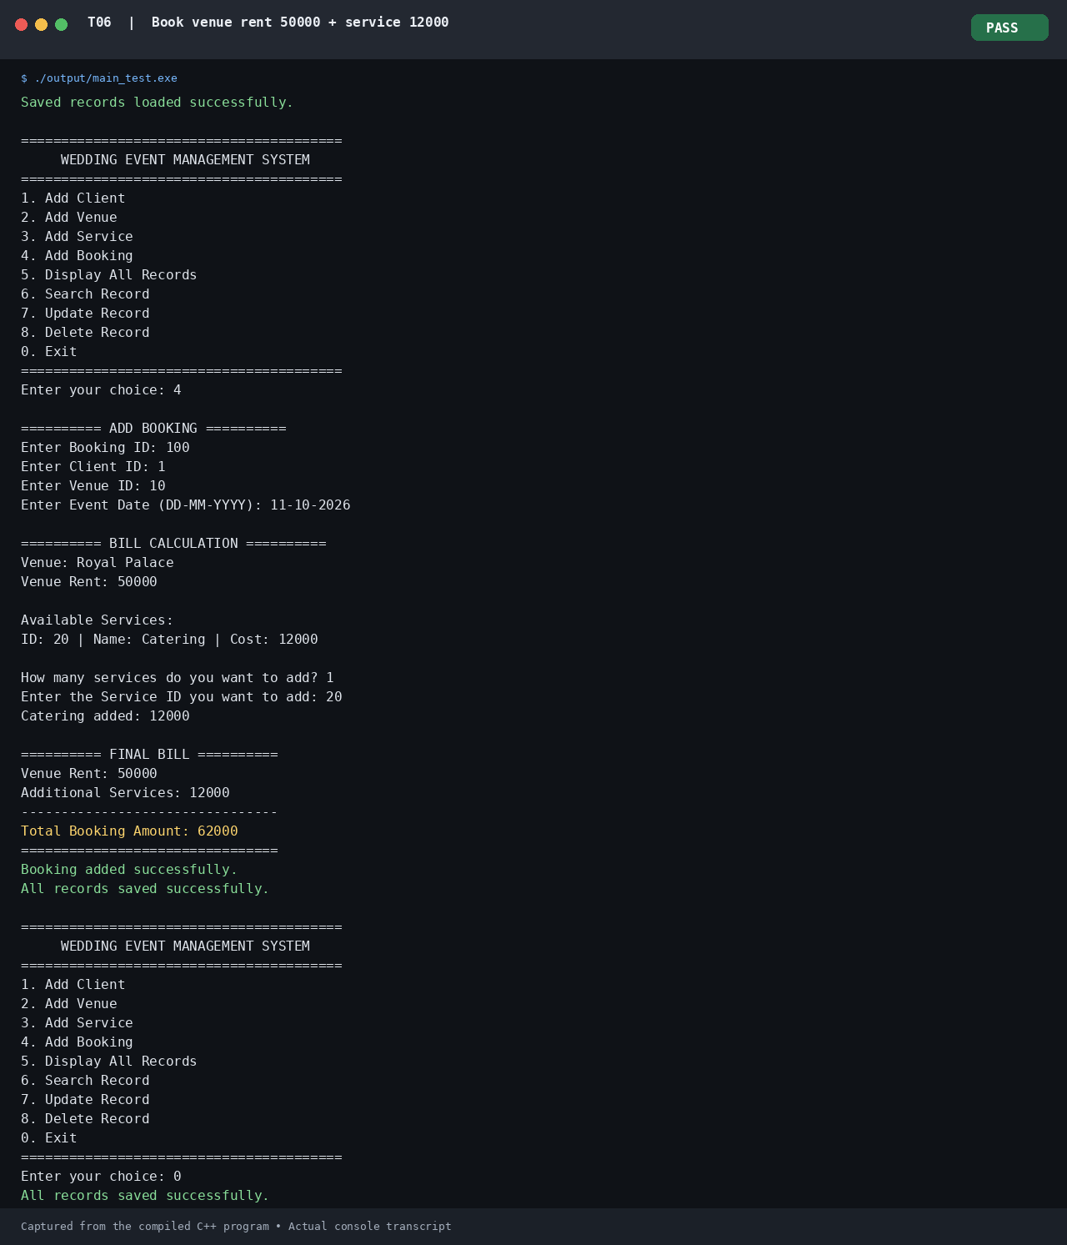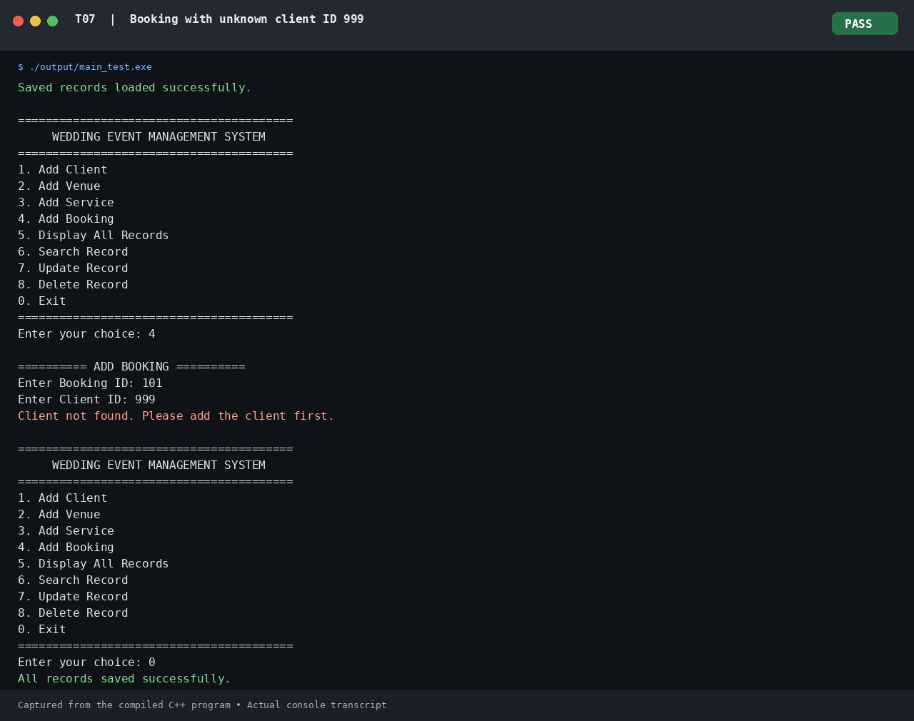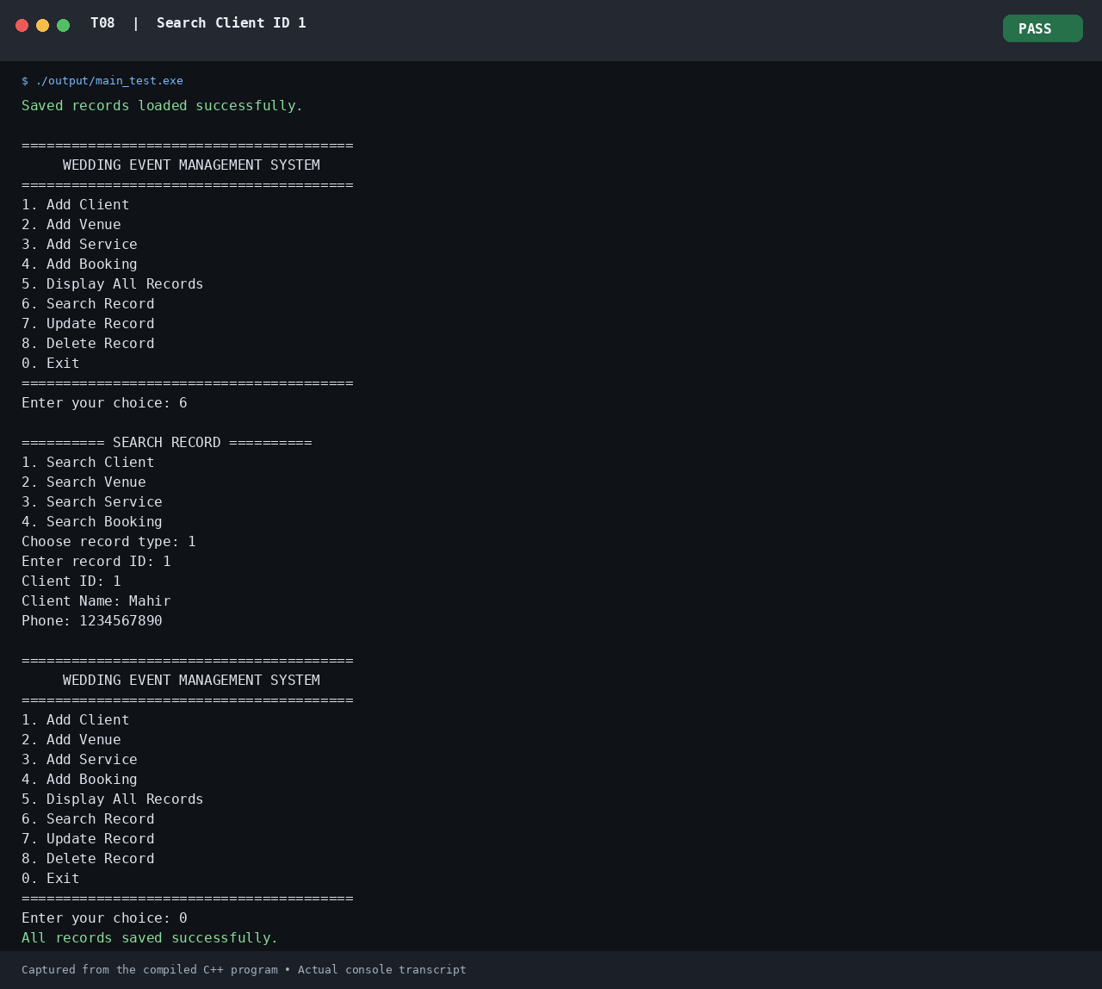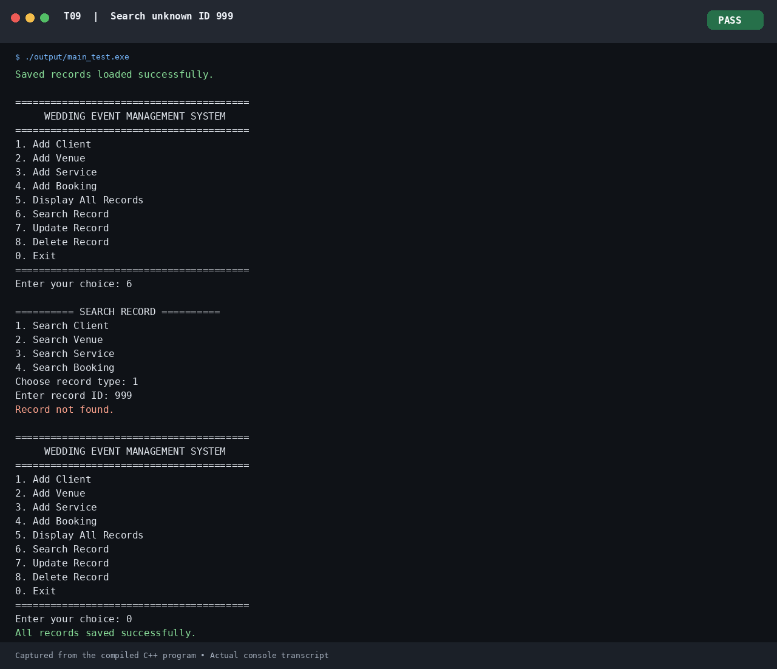
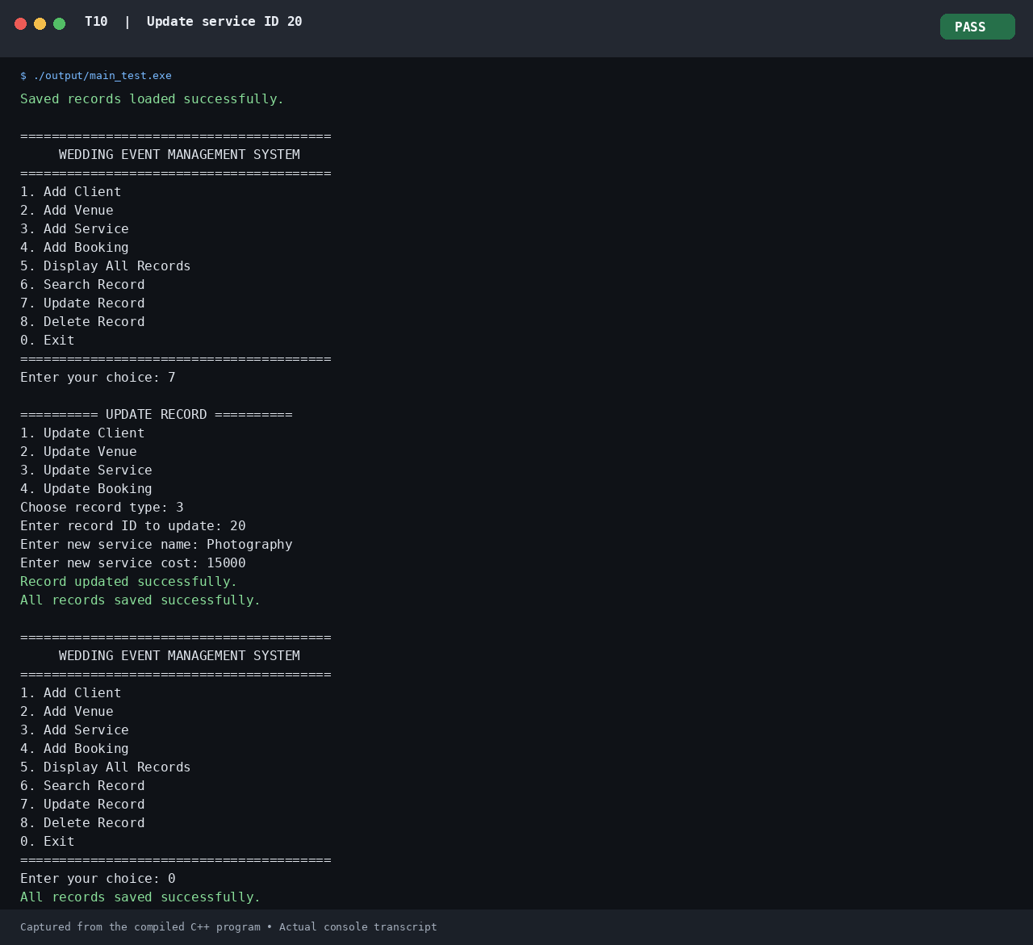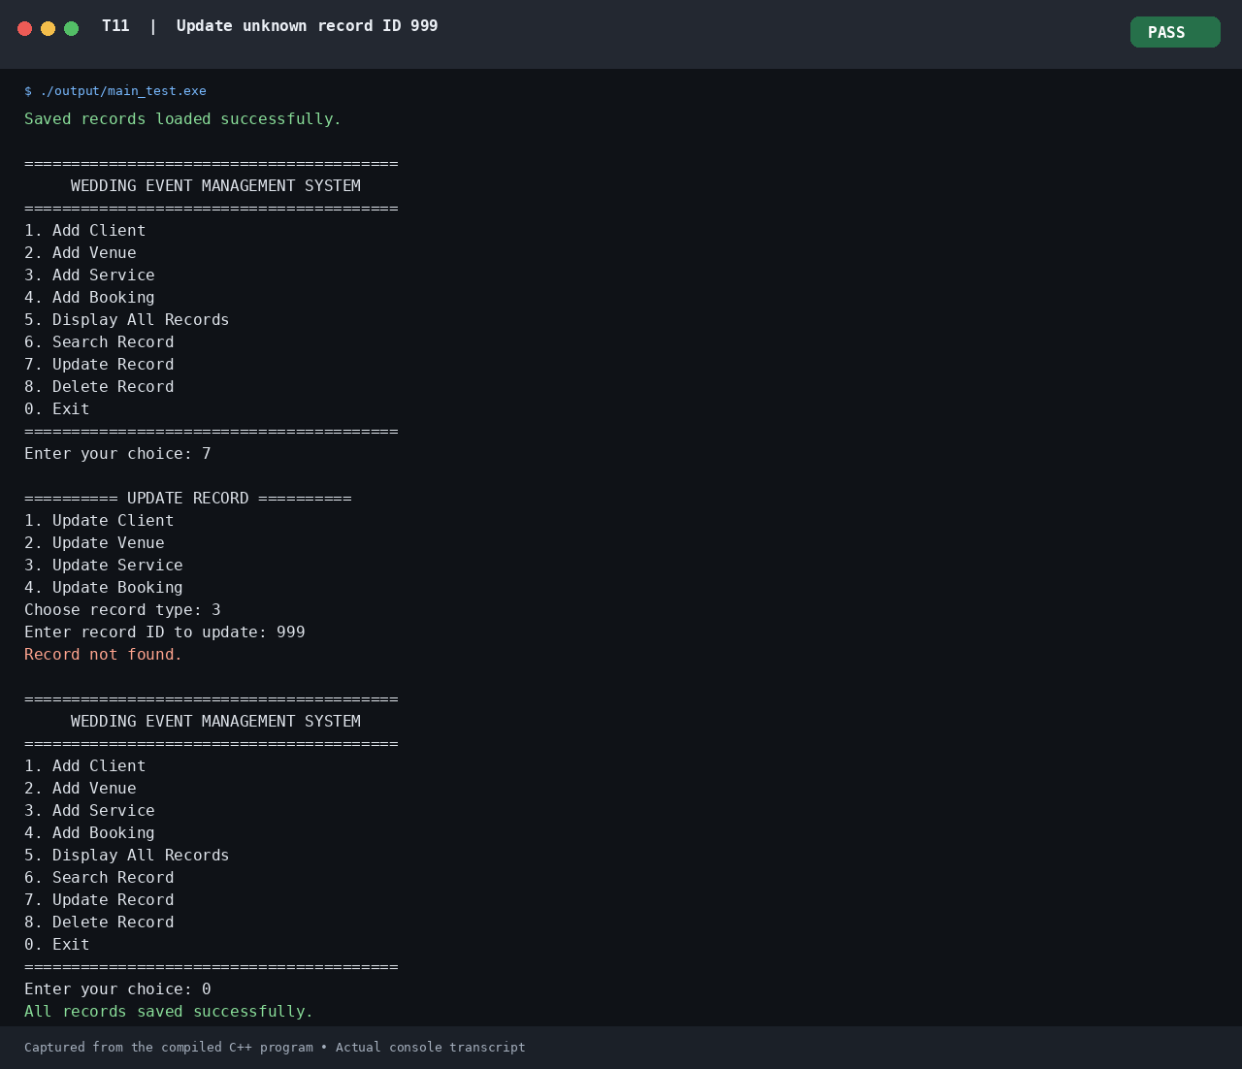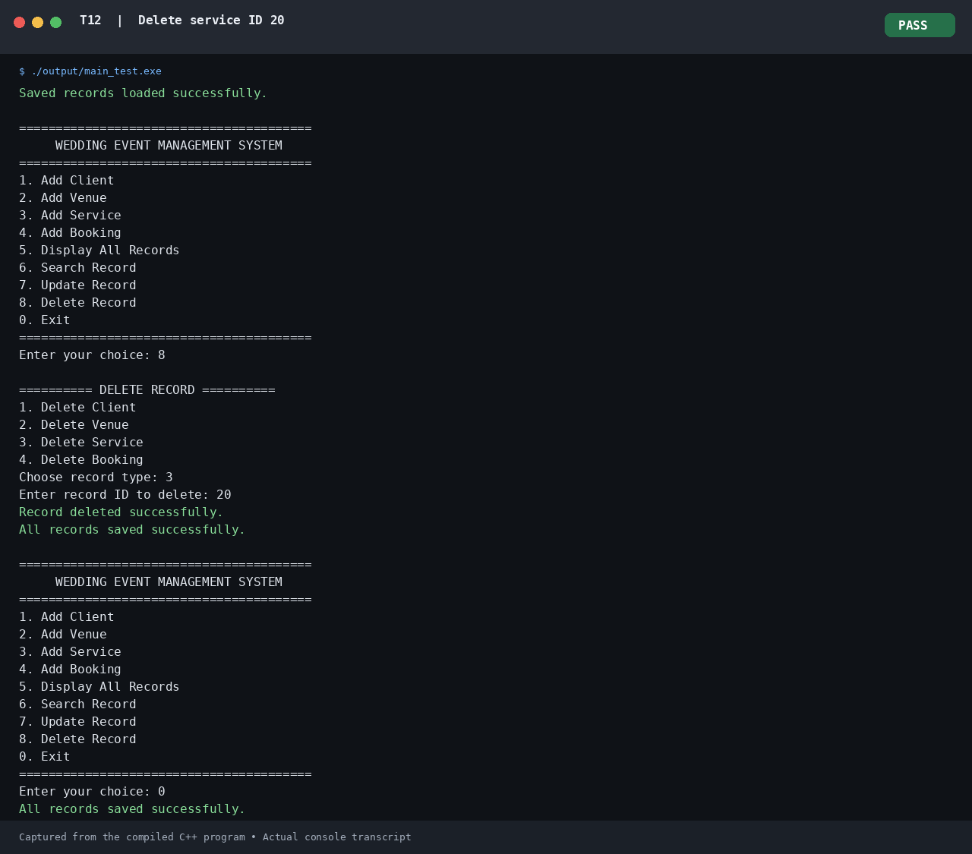
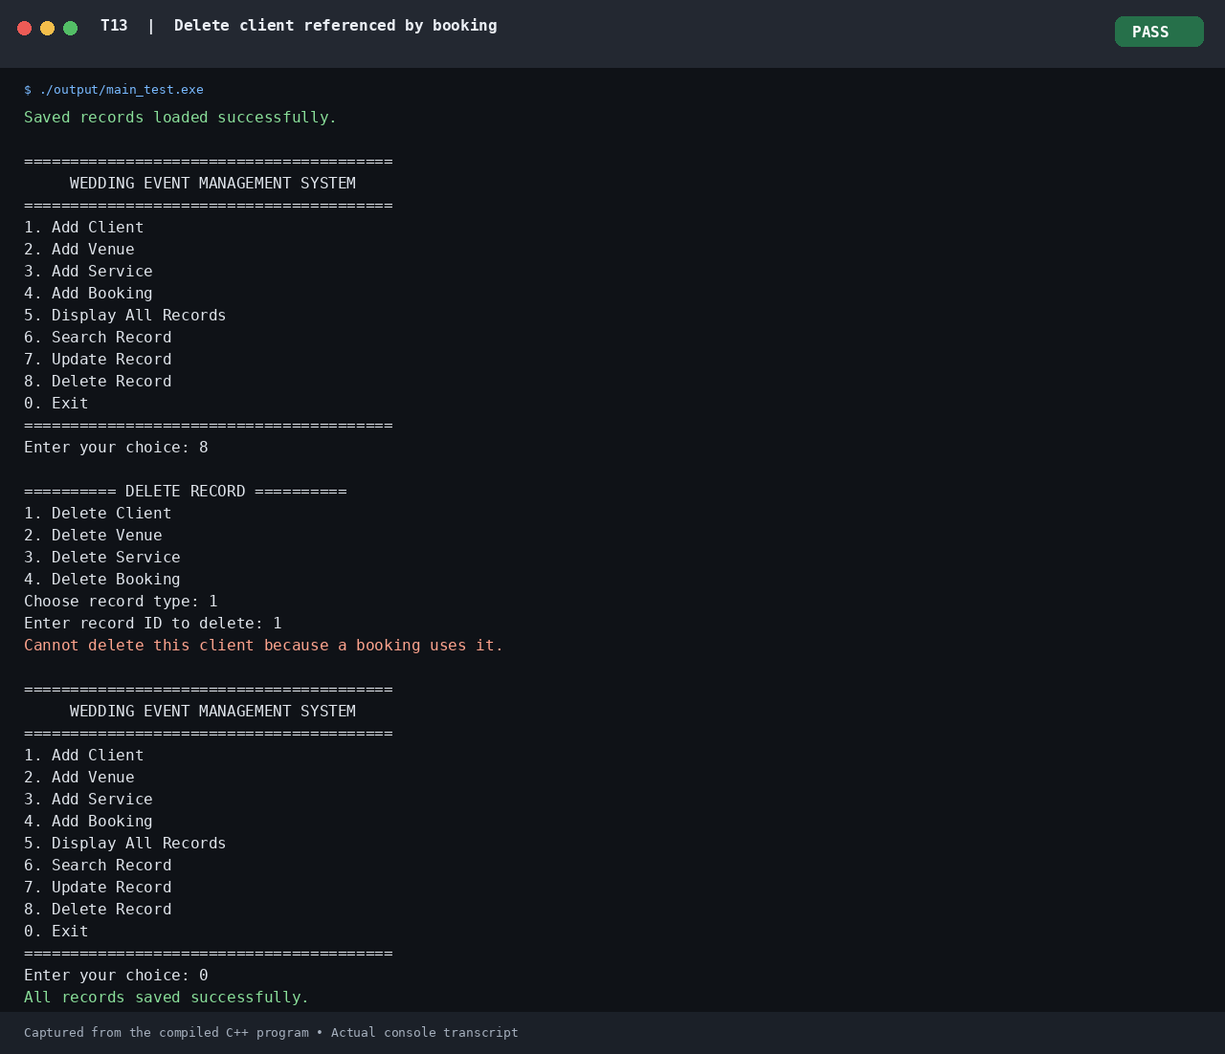
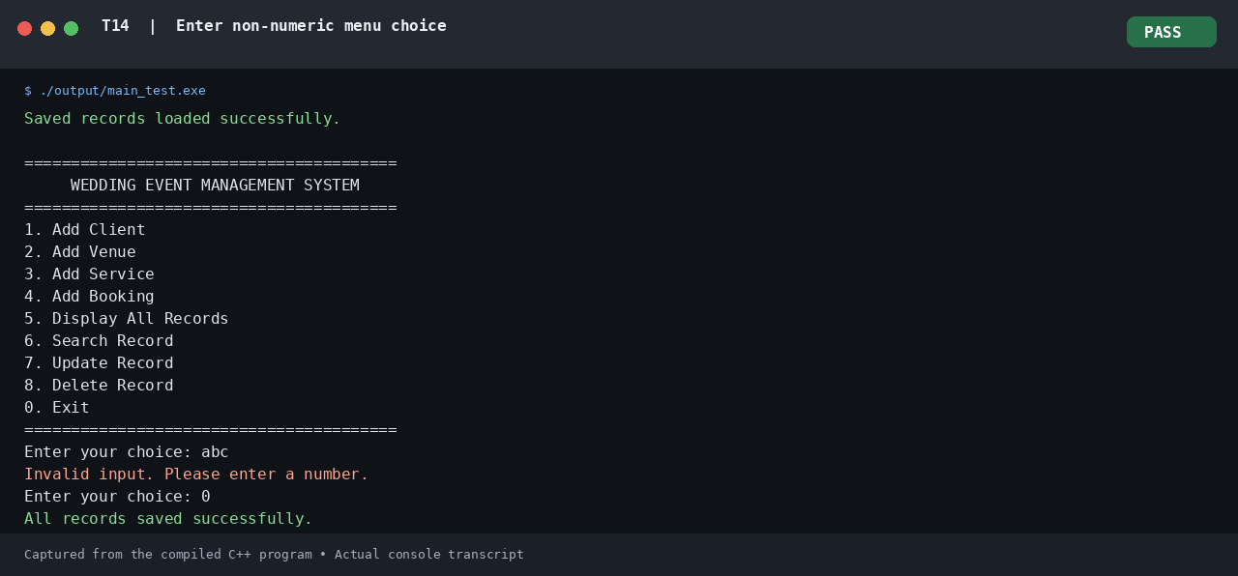
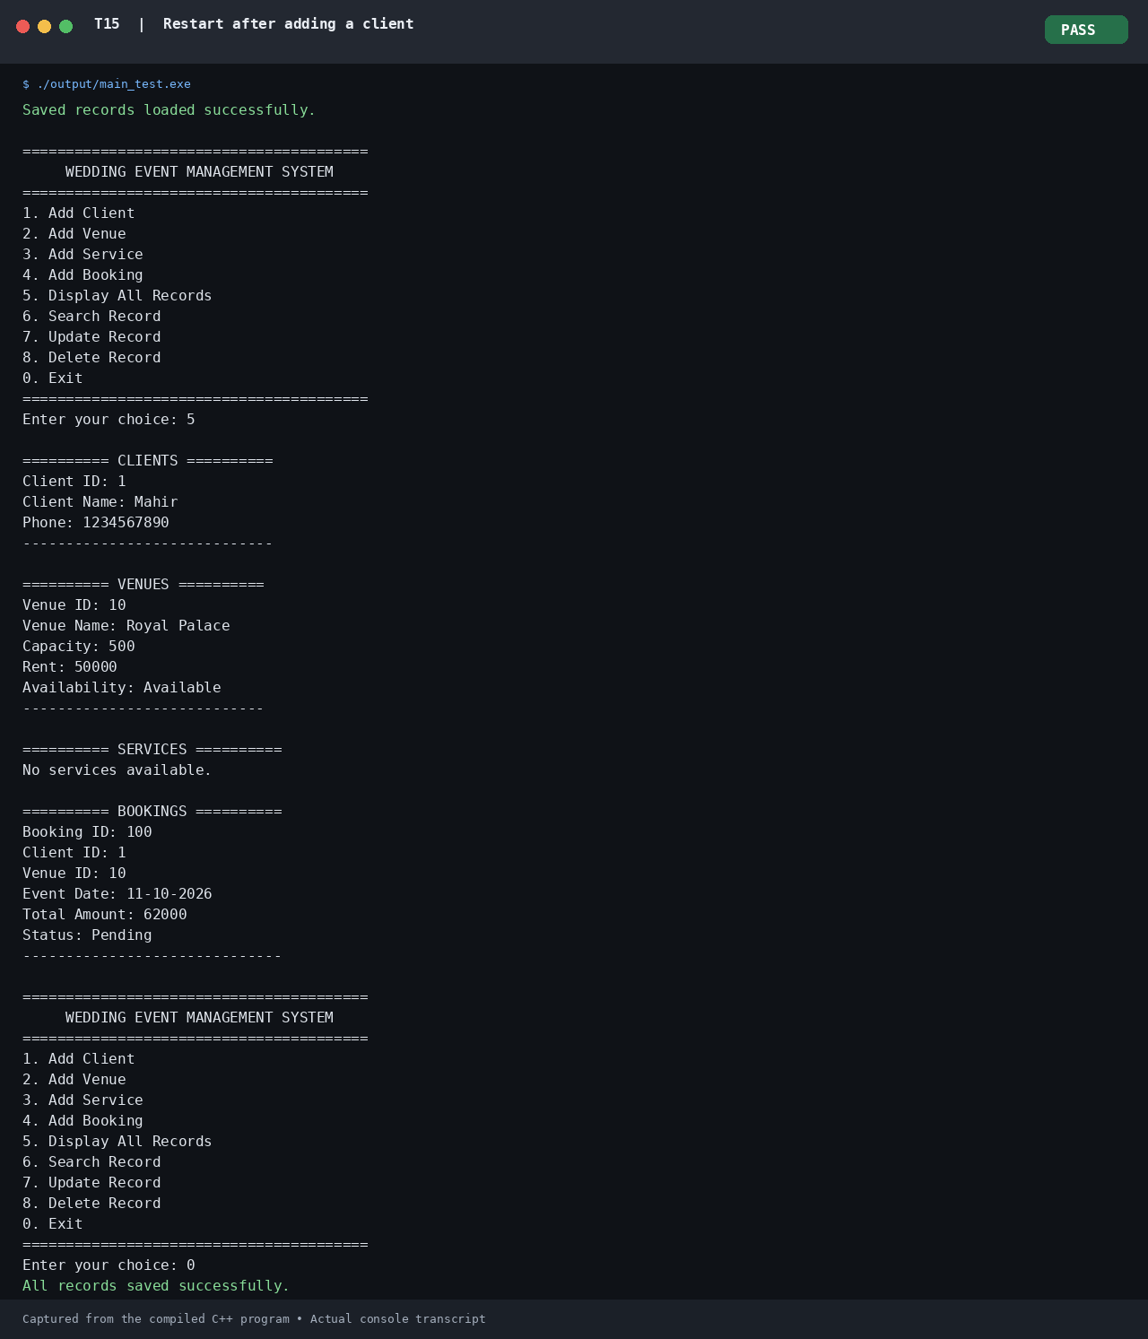

13. Limitations

Although the Wedding Event Management System provides essential functions for managing clients, venues, services, and bookings, it has certain limitations.
- Console-Based Interface: The application uses a text-based console interface, which may be less convenient for users than a graphical or web-based application.
- Limited Record Capacity: The system uses dynamically allocated arrays with a maximum capacity of 100 records for each collection. This limits the total number of clients, venues, services, and bookings that can be stored.
- Local File Storage: The application stores records in local text files rather than a database. This provides basic persistence but offers limited support for advanced data management and recovery.
- No User Authentication: The system does not provide login functionality or role-based access control. Therefore, it does not distinguish between administrators and customers.
- No Online Booking Interface: Customers cannot directly access the application through a website or mobile application. Booking operations are performed by the wedding event manager through the console.
- Limited Availability Checking: Venue availability is managed through an availability status. The system does not provide a complete calendar-based mechanism for detecting date and time conflicts between bookings.
- Limited Booking Details: The Booking class stores the client ID, venue ID, event date, total amount, and confirmation status, but does not separately store the IDs of all selected services.
- No Online Payment Integration: The application calculates and displays the booking amount but does not support online payment processing or payment-status tracking.
- Single-User Operation: The application is designed for local, console-based use and does not provide concurrent access for multiple users.
- Basic Reporting Facilities: The system provides record display and booking bill information but does not include advanced financial reports, graphical summaries, or detailed business analytics.
These limitations define the current scope of the project and provide opportunities for future improvements.

14. Future Scope

The Wedding Event Management System can be enhanced in the future by introducing additional features and technologies to improve its usability, reliability, and efficiency.
- Graphical User Interface: A graphical interface can be developed to make the application easier to use and more visually appealing.
- Database Integration: The current text-file storage system can be replaced with a database such as MySQL to support structured storage, efficient searching, and improved data management.
- User Authentication: Login functionality and role-based access can be introduced to provide separate access for administrators and customers.
- Online Booking System: A web or mobile application can be developed to allow customers to browse venues, explore wedding services, check availability, and create booking requests directly.
- Advanced Venue Availability: A calendar-based booking system can be implemented to detect overlapping bookings and manage venue availability according to event dates and time slots.
- Improved Booking Management: The system can be enhanced to store the individual services selected for each booking and provide more detailed booking information.
- Online Payment Integration: Secure payment facilities can be added to process payments, maintain payment records, and track booking payment status.
- Automated Notifications: Email or SMS notifications can be introduced to inform customers about booking confirmations, changes, reminders, and cancellations.
- Advanced Reports and Billing: The system can generate detailed invoices, booking summaries, revenue reports, and service-wise cost analyses.
- Improved Scalability and Security: Dynamic arrays can be replaced with suitable STL containers or database-backed structures, along with stronger input validation, backup facilities, and improved error handling.
These enhancements can transform the current console-based application into a more comprehensive wedding event management solution suitable for larger numbers of users and more complex booking requirements.

15. Conclusion

The Wedding Event Management System was developed using C++ to simplify the management of clients, venues, wedding services, and bookings. The application provides a menu-driven interface through which the wedding event manager can add, display, search, update, and delete records, as well as create bookings and calculate the total booking amount.
The project demonstrates important Object-Oriented Programming concepts, including classes and objects, encapsulation, inheritance, polymorphism, constructors, and destructors. Dynamic memory allocation is used to manage record collections, while file handling allows client, venue, service, and booking data to be saved and loaded using text files.
The system combines different classes to create a modular structure, with EventManager coordinating application operations and FileManager handling data persistence. Through this project, practical knowledge of C++ programming, object-oriented design, input validation, record management, and file operations has been applied to a real-world management scenario.
Although the current application has limitations, such as a console-based interface, fixed record capacity, and local text-file storage, it provides a useful foundation for further development. Future enhancements could include database integration, a graphical interface, online booking, advanced availability checking, and payment processing.
In conclusion, the project successfully demonstrates the practical application of C++ programming concepts in developing a basic wedding event management solution.

